A.A.GOVERNMENT ARTS COLLEGE, MUSIRI.

Affiliated to Bharathidasan University,Tiruchirappalli.

NAAN MUDHALVAN PROJECT – III B.SC MATHEMATICS

TOPIC:

*ANALYSING HOUSING PRICES IN METROPOLITAN AREA OF INDIA*

*Submitted by*

TEAM ID: NM2023TMID08632

TEAM LEADER: HARSHINI.M(47FCD49F5C0EF9C96AA43A2A57E53FC0)

MEMBERS:1. PAVITHRA.R (B592A696893FA21AA33487581A79FAED)

2. AATHIPARASAKTHI.D(5B7A49B6F07DA0382374575A21B0A099)

3. KAVYA.K (0538409B5B90840BFD446A7F01A03784)

*INTRODUCTION*

Fact of rapid urbanisation and regional disparities, it is not unexpected that it may lead to some sort of differences in regional house price, where housing and real estate are considered as major sources of physical and financial asset. This also leads to the differences in the dynamics of house price determination. It simply means that there might be shift of house prices in cities from average, in the country depending upon its economic status.

REFERENCE:

* Im, K. S., Pesaran, M. H. and Shin, Y. (2003). Testing for unit roots in heterogeneous panels. Journal of Econometrics, 115: 53-75.
* Iyer, K. (2011). Technology gap, catching-up and outward orientation: Analysis of 63 countries. Journal Applied Econometrics and International Development, 11(2): 1-20.
* Khokhar, J.S. (2010). Will India’s trade deficit ever converge to zero? An application of bounds testing approach to co-integration. Journal Applied Econometrics and International Development, 10(1): 210-218.
* Lee, C. and Chien, M. (2011). Empirical modelling of regional house prices and the ripple effect. Urban Studies, 48(10): 2029– 2047.
* Levin, A., Lin, C.-F. and Chu, S.-S. J. (2002). Unit root tests in panel data: asymptotic and finite-sample properties. Journal of Econometrics, 108: 1-24.

*Milestone 1: Define Problem / Problem Understanding*

Activity 1: Specify the business problem

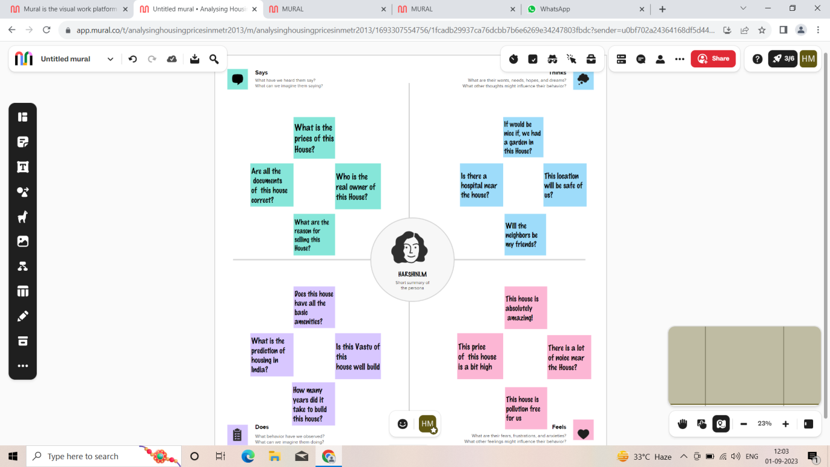

Activity 2: Business requirements

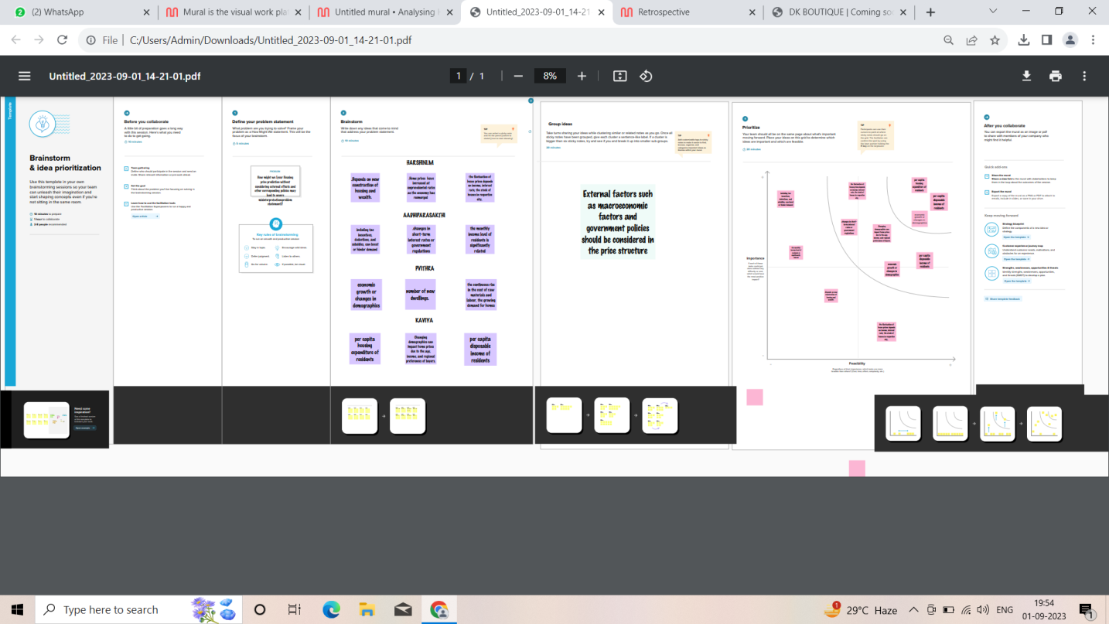

*Milestone 2: Data Collection*

Activity 1: Downloading the dataset

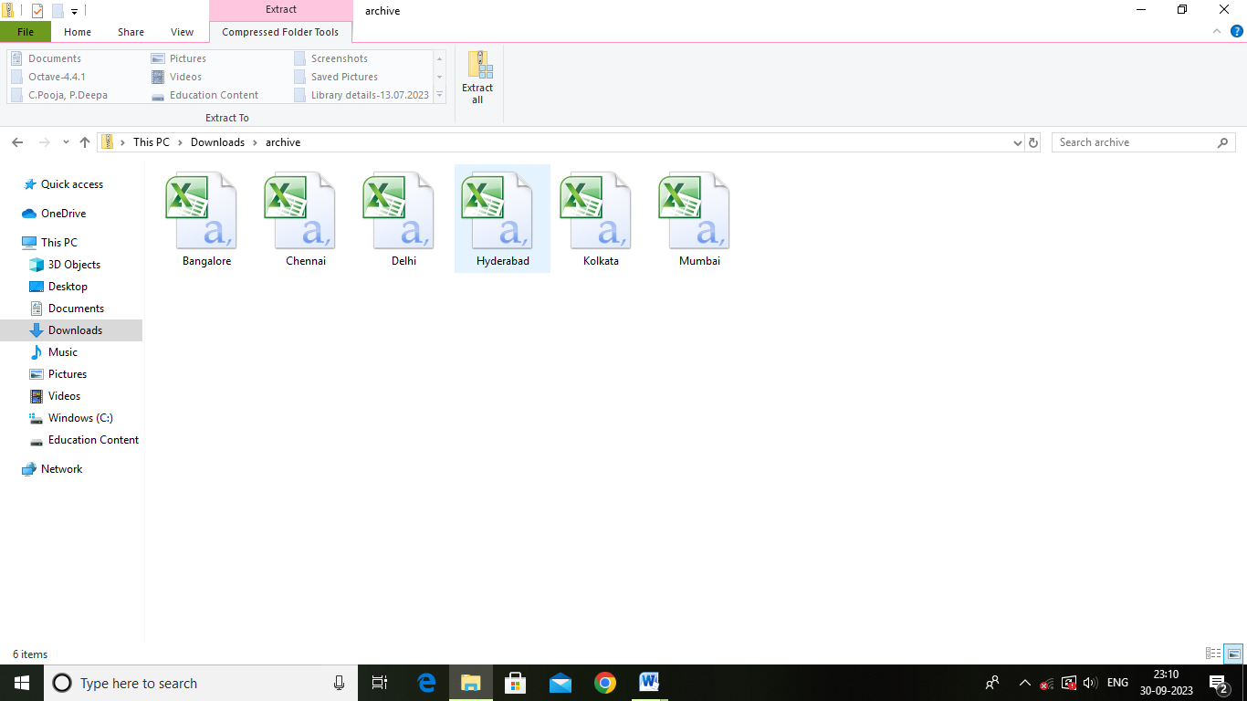

Activity 2: Connect Dataset with Tableau

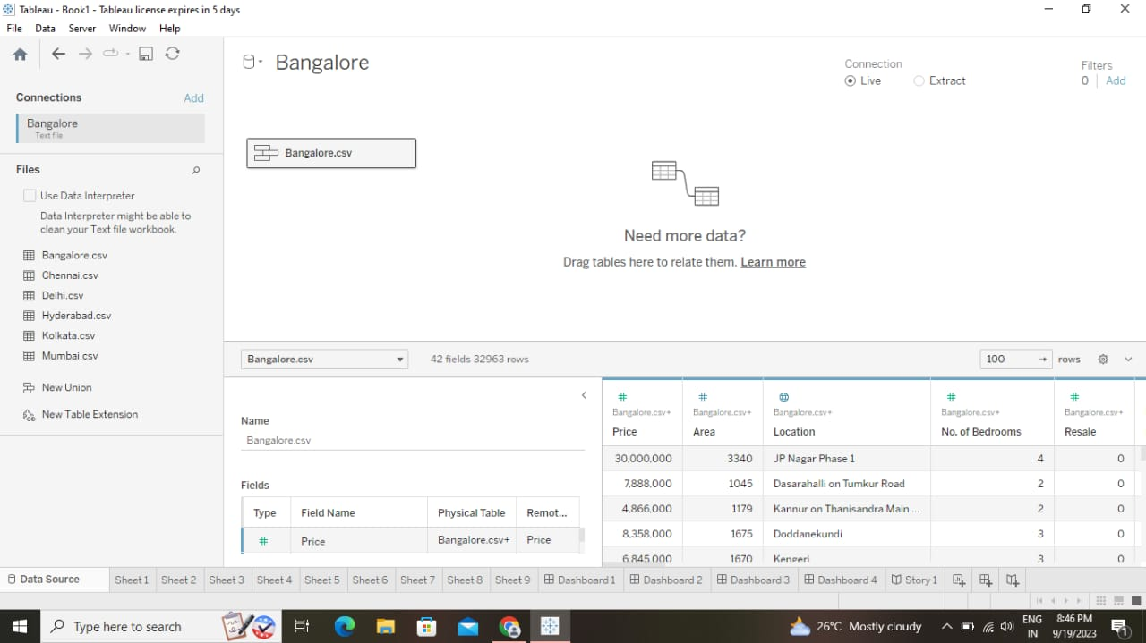

*Milestone 3: Data Preparation*

Activity 1: Prepare the Data for Visualization

This process helps to make the data easily understandable and ready for creating visualizations gain insights into performance and efficiency.

*Milestone 4: Data Visualization*

Data visualization is the representation of data through use of common graphics, such as charts, plots, infographics, and even animations.

Activity 1: Number of Unique Visualization

The number of unique visualizations that can be created with a given dataset.

Activity 1.1: Latitude and Longitude based on Location

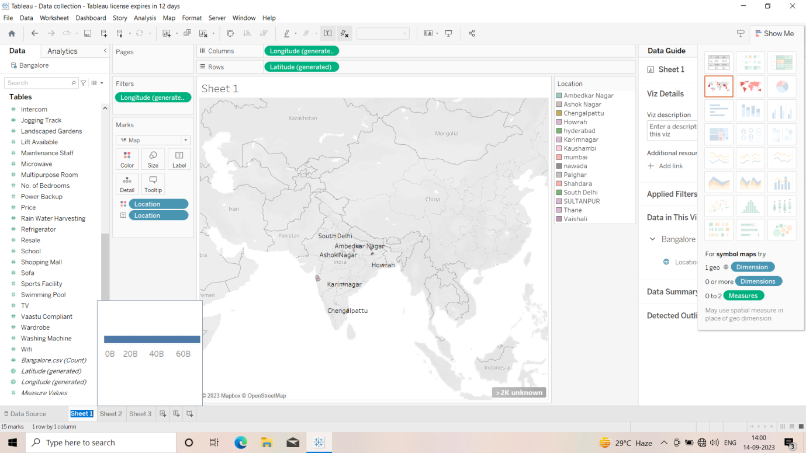

Activity 1.2: Number of houses based on area in sqf

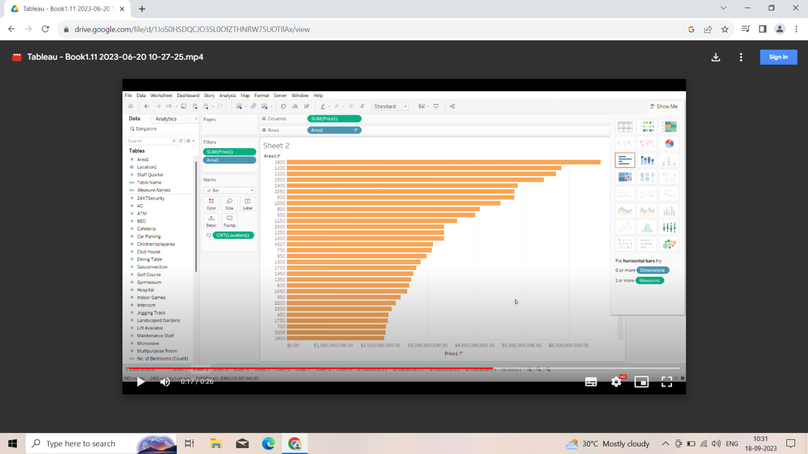

Activity 1.3: Houses price based on rainwater harvest pits

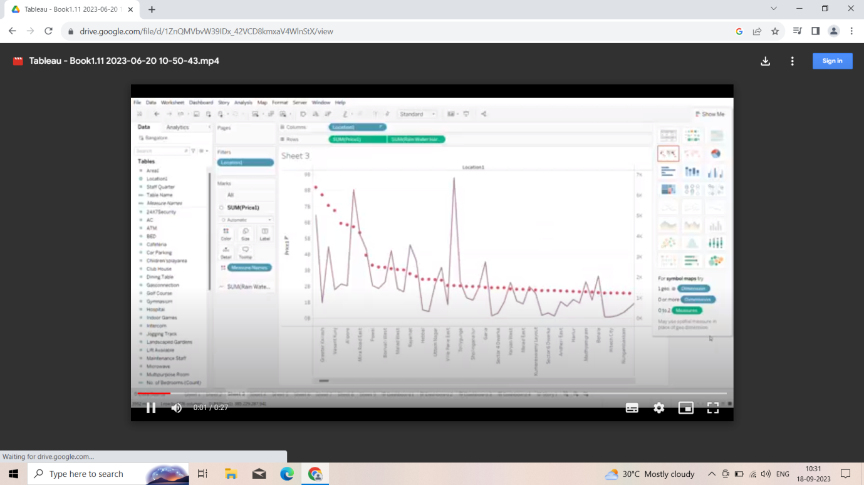

Activity 1.4: Vastu-complains based on location

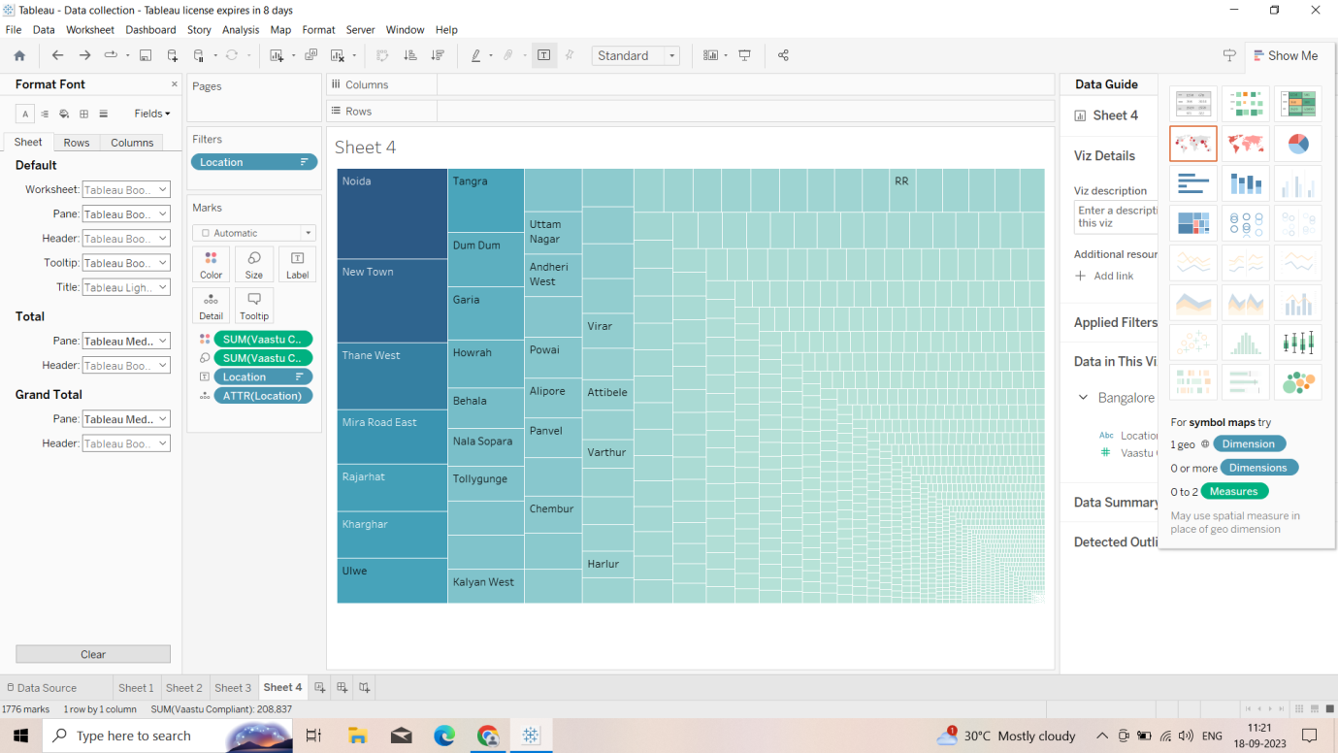

Activity 1.5: House price based on Number of Bedrooms

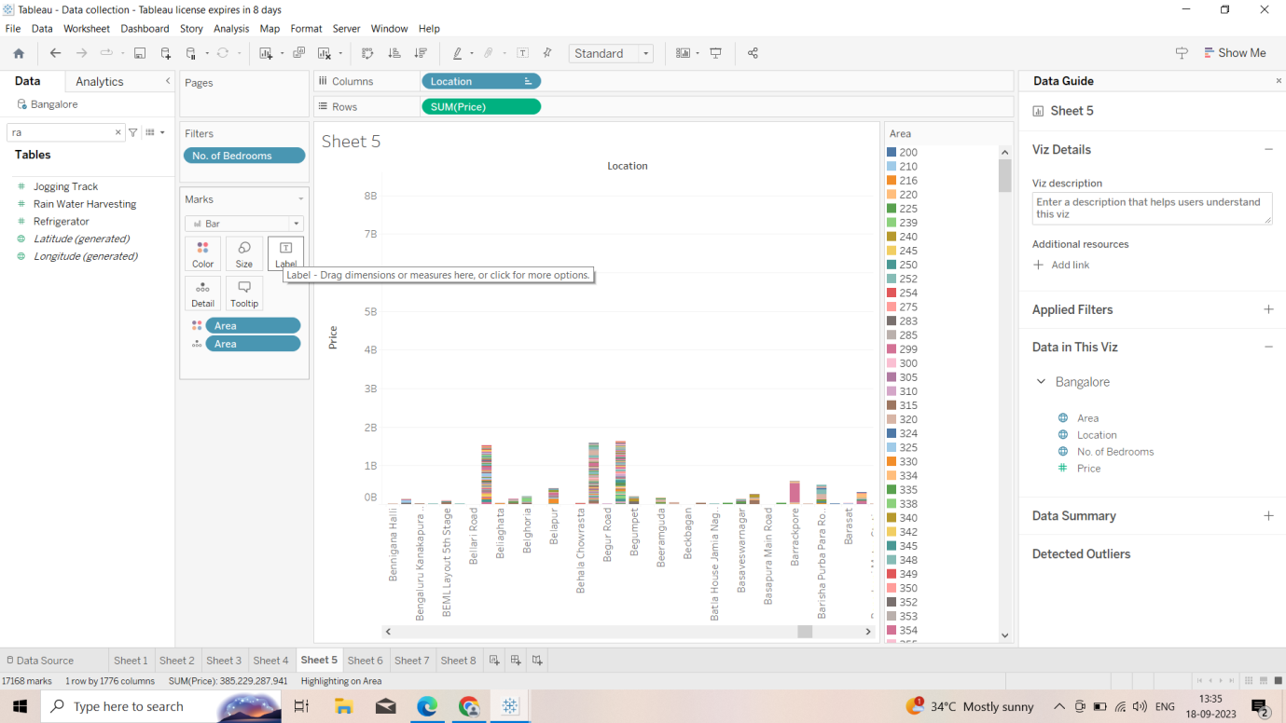

Activity 1.6: Hospitals and Schools near the Houses

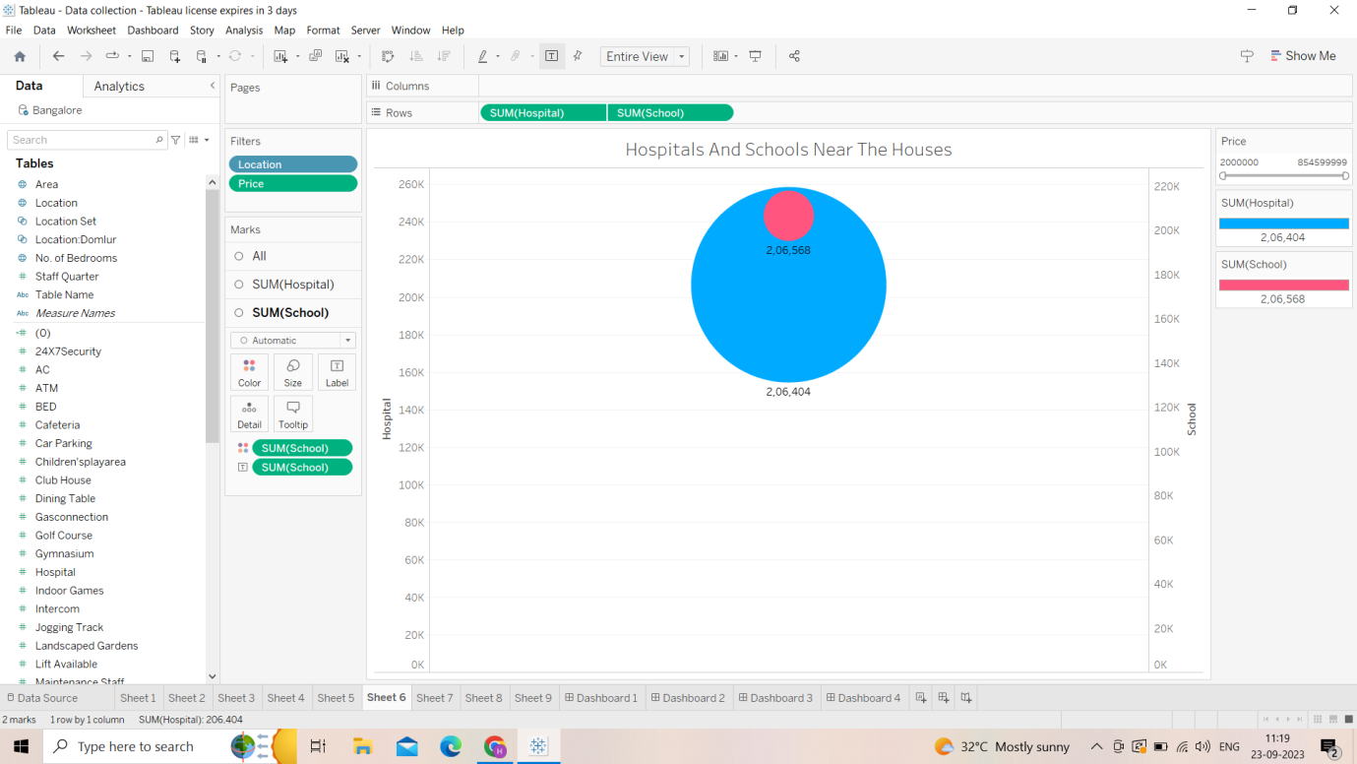

Activity 1.7: Maintains staff in houses prices

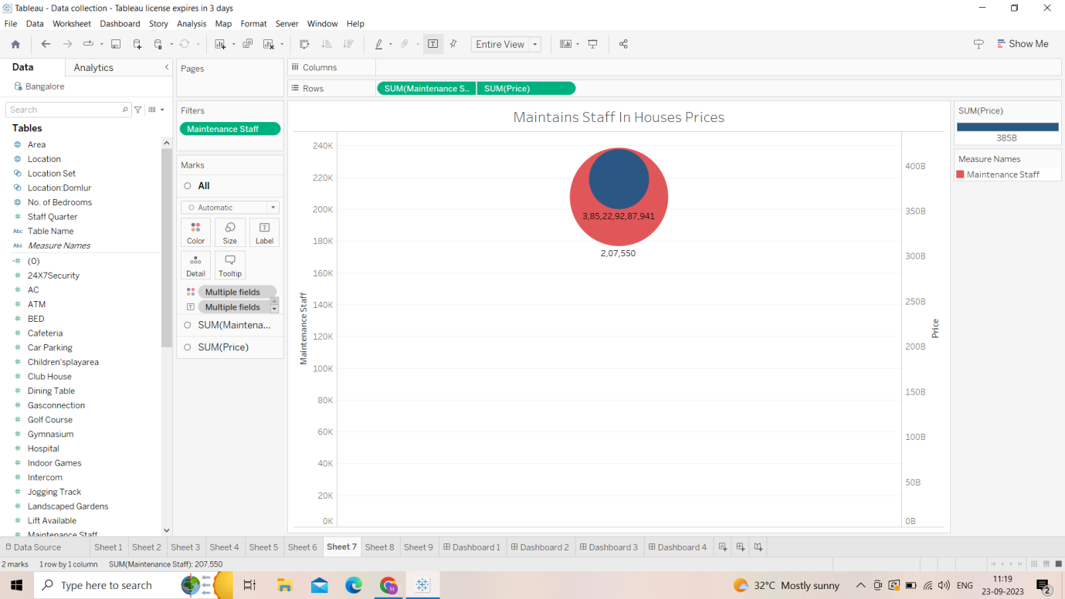

Activity 1.8: House Price and Intercom

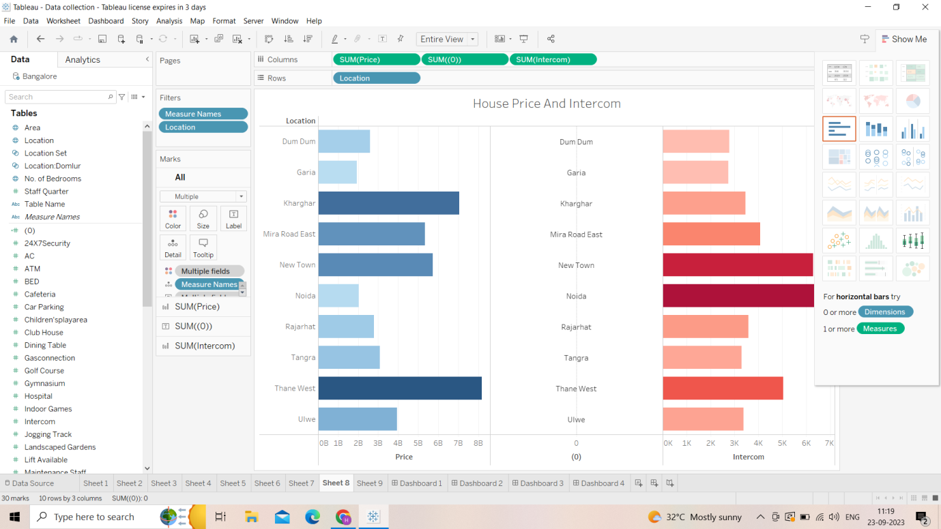

Activity 1.9: All Service based on Locations

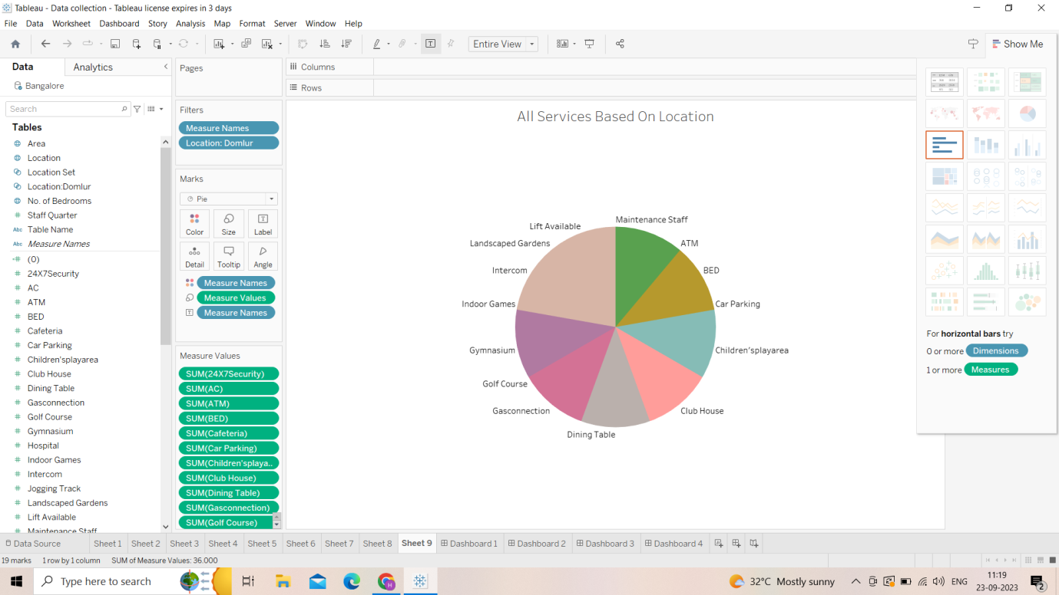

*Milestone 5: Dashboard*

A dashboard is a graphical user interface that displays information and data in an organized, easy-to-read format.

Activity 1- Responsive and Design of Dashboard

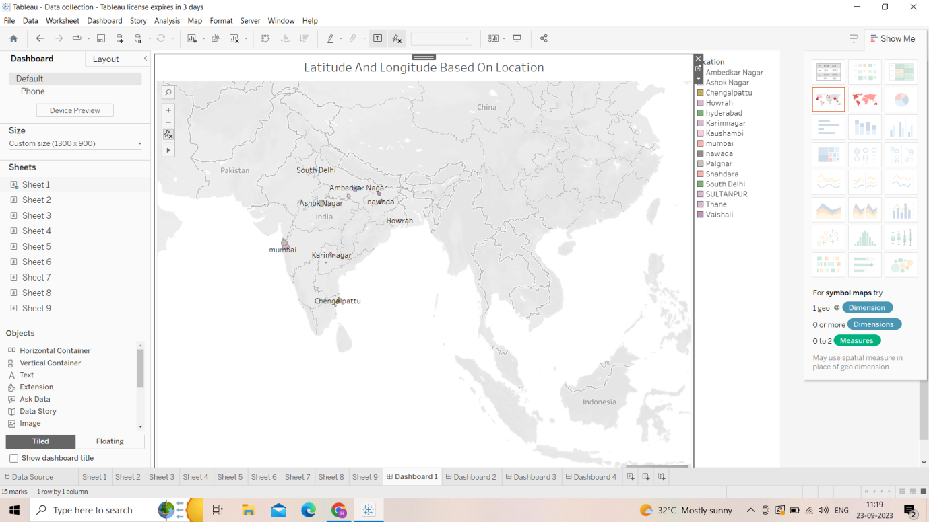

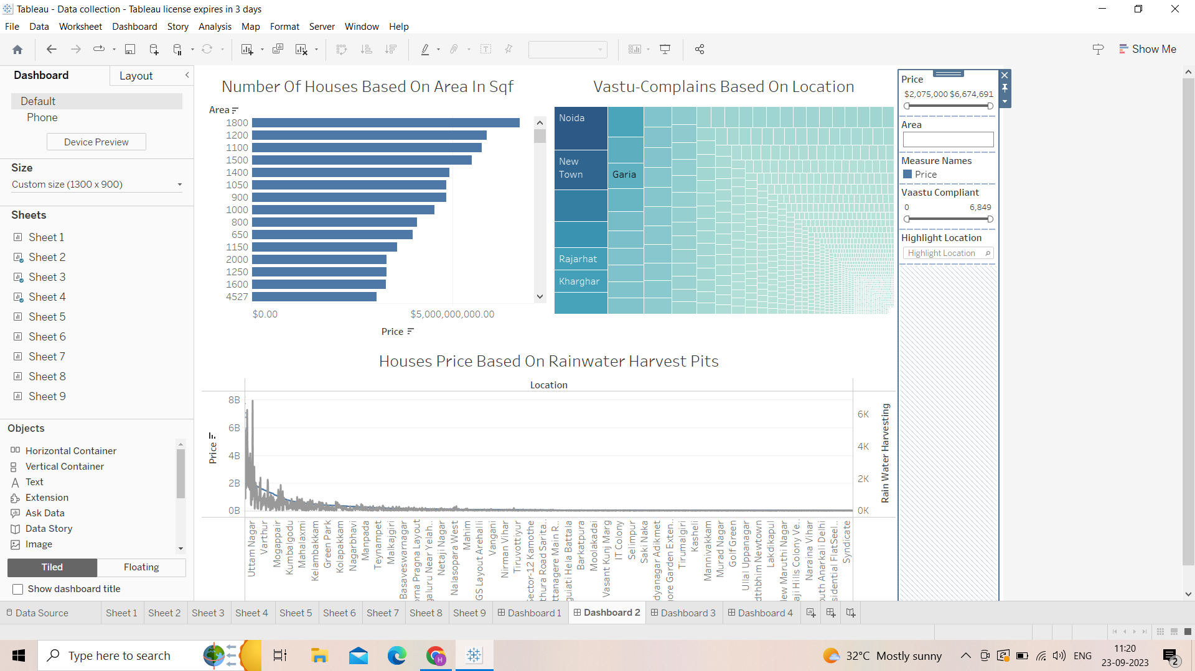

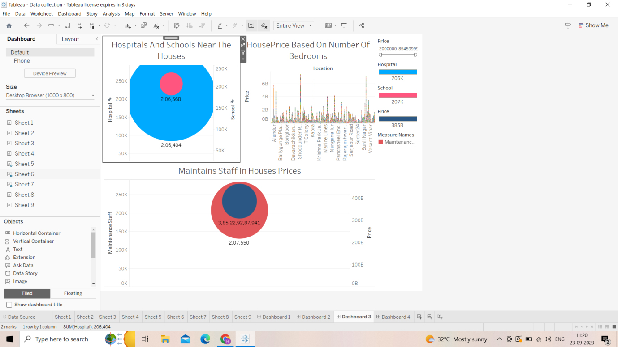

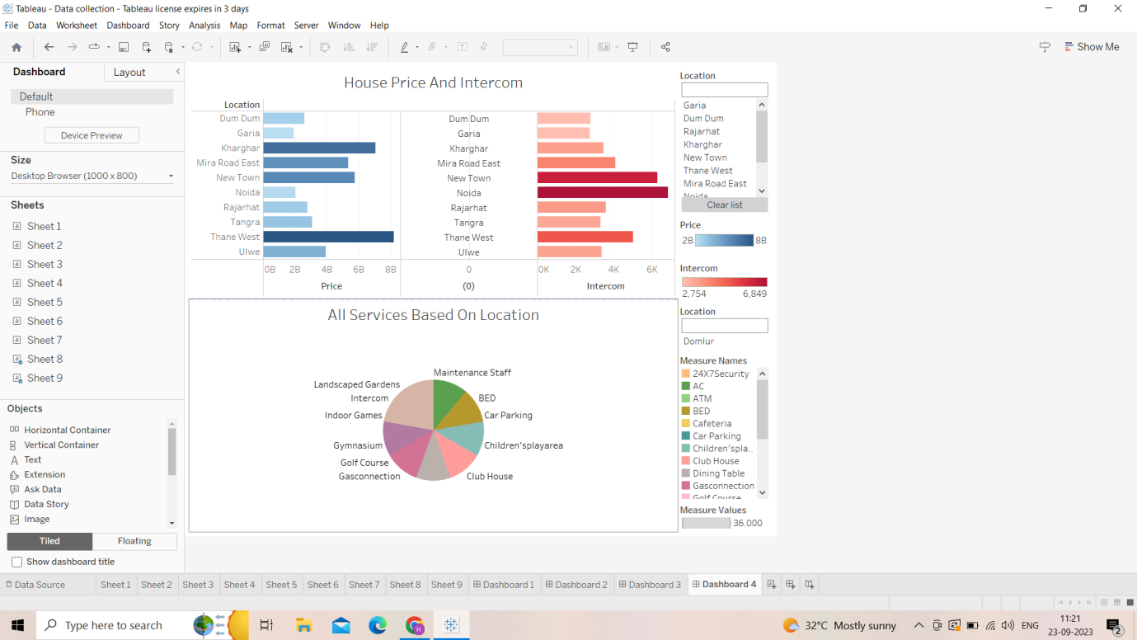

*Milestone 6: Story*

Activity 1: Number of Scenes of Story

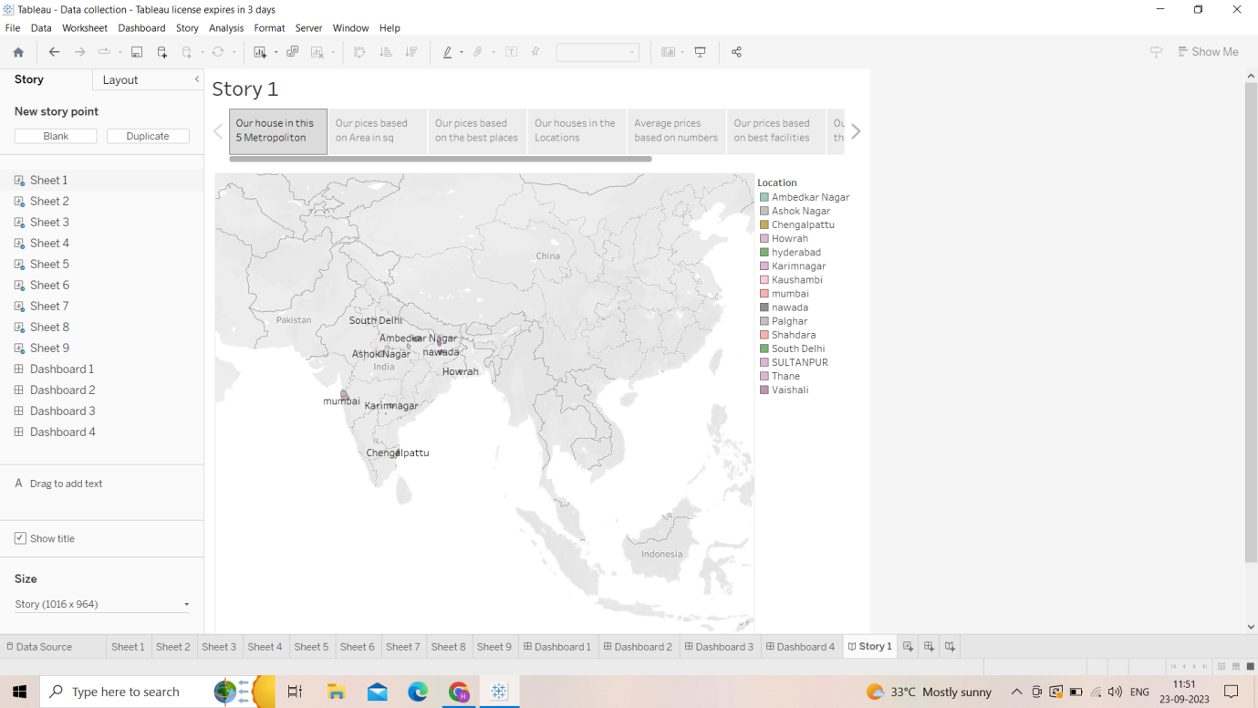

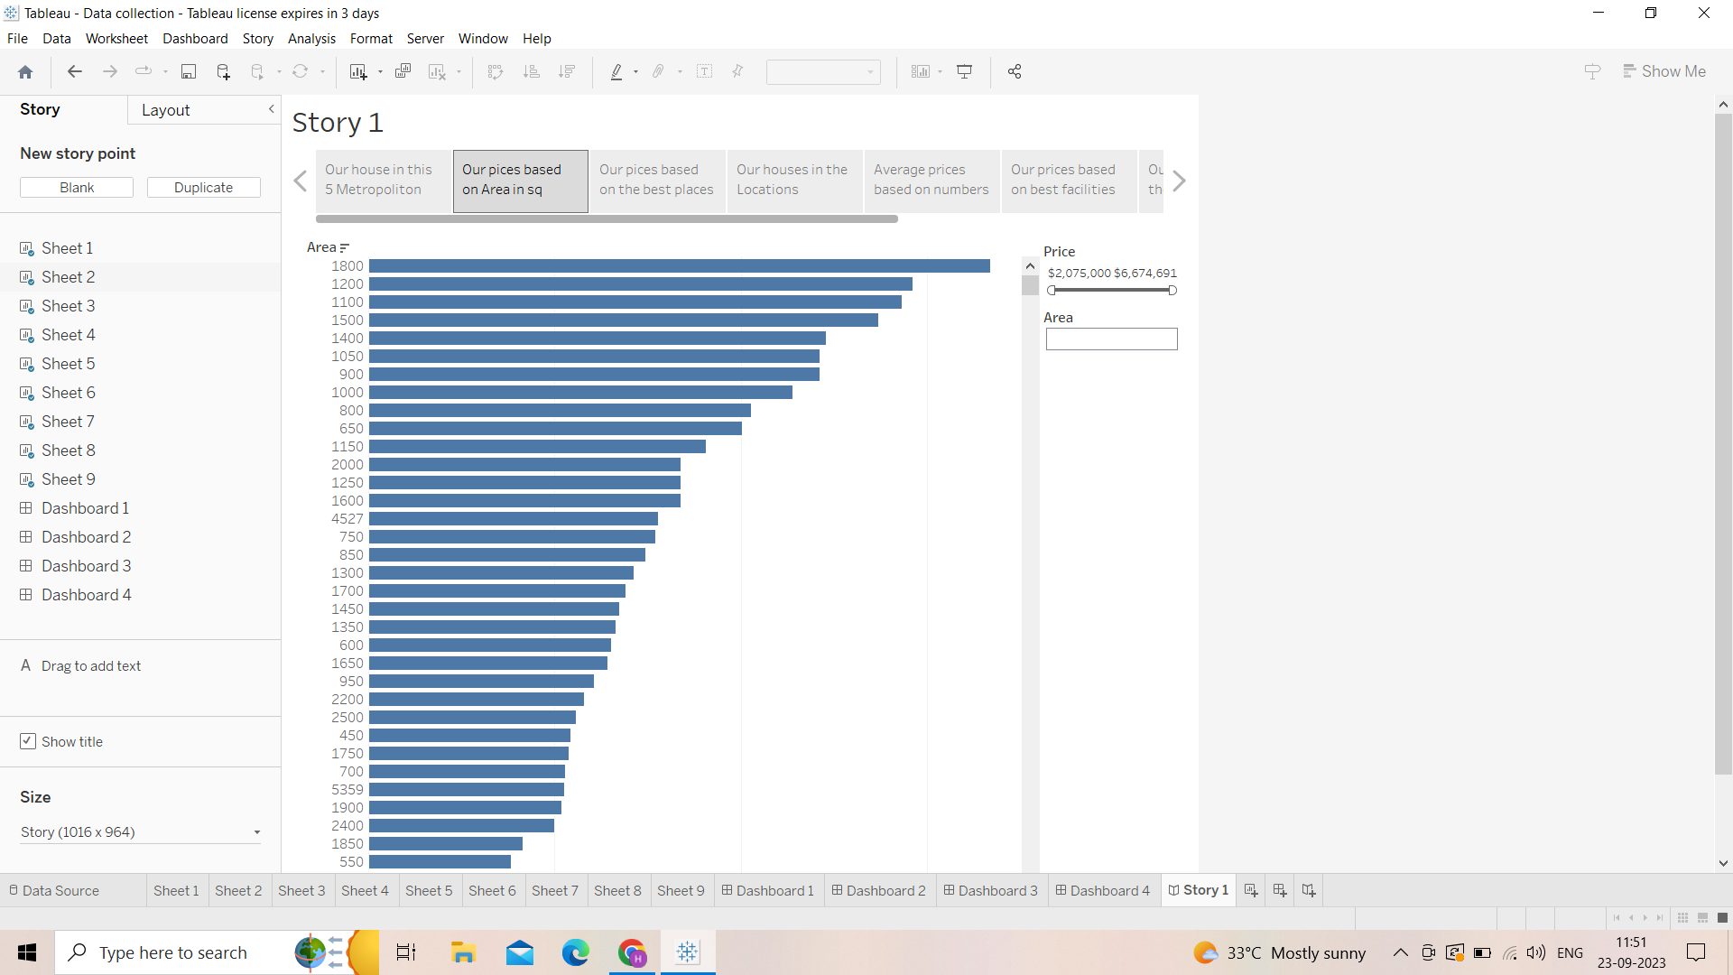

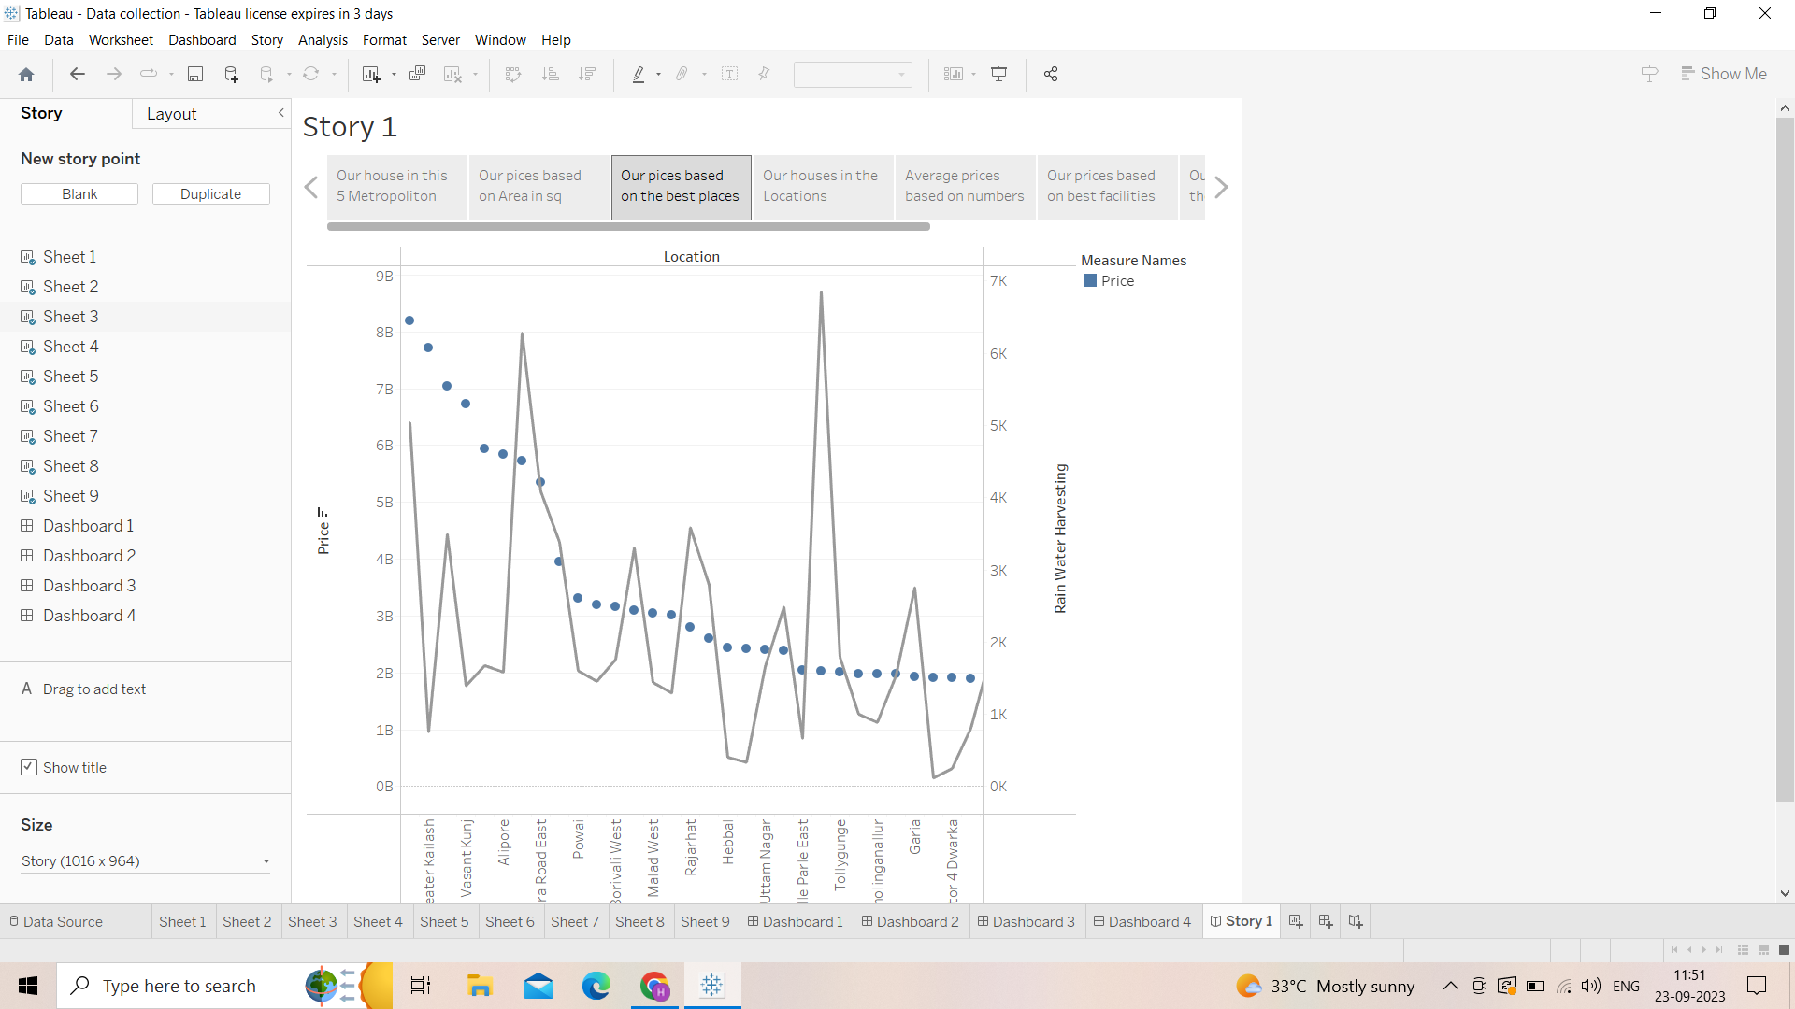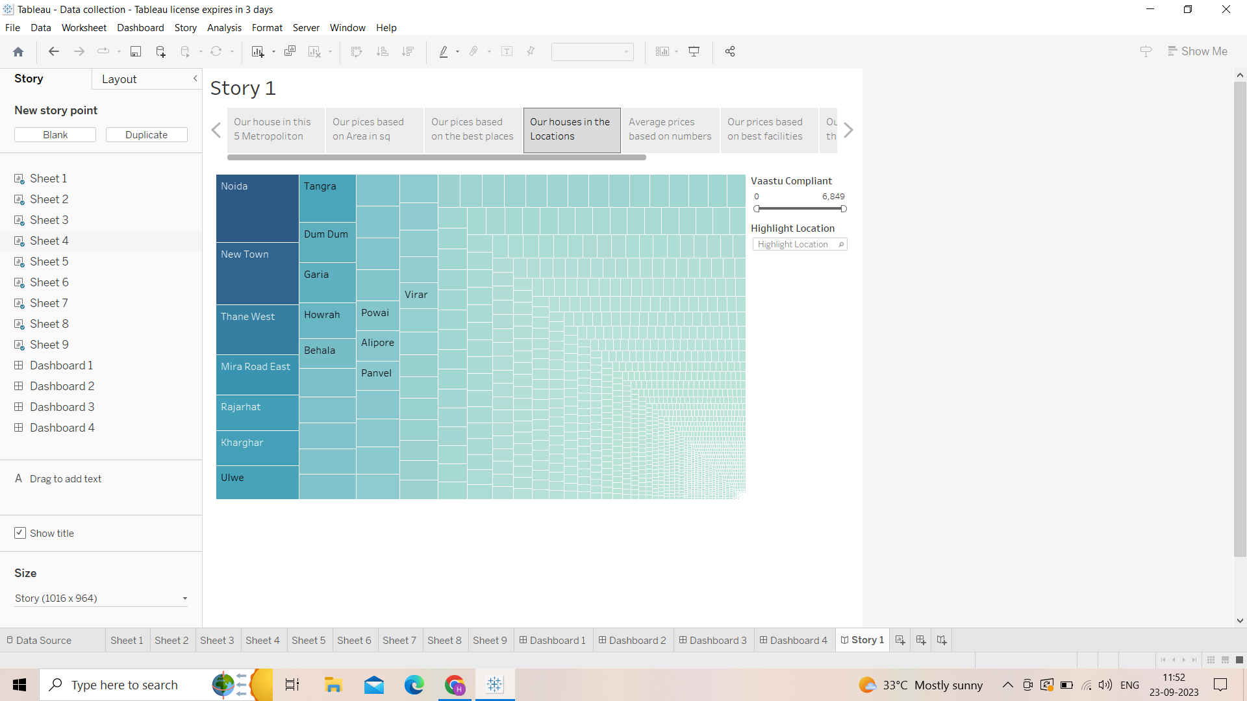

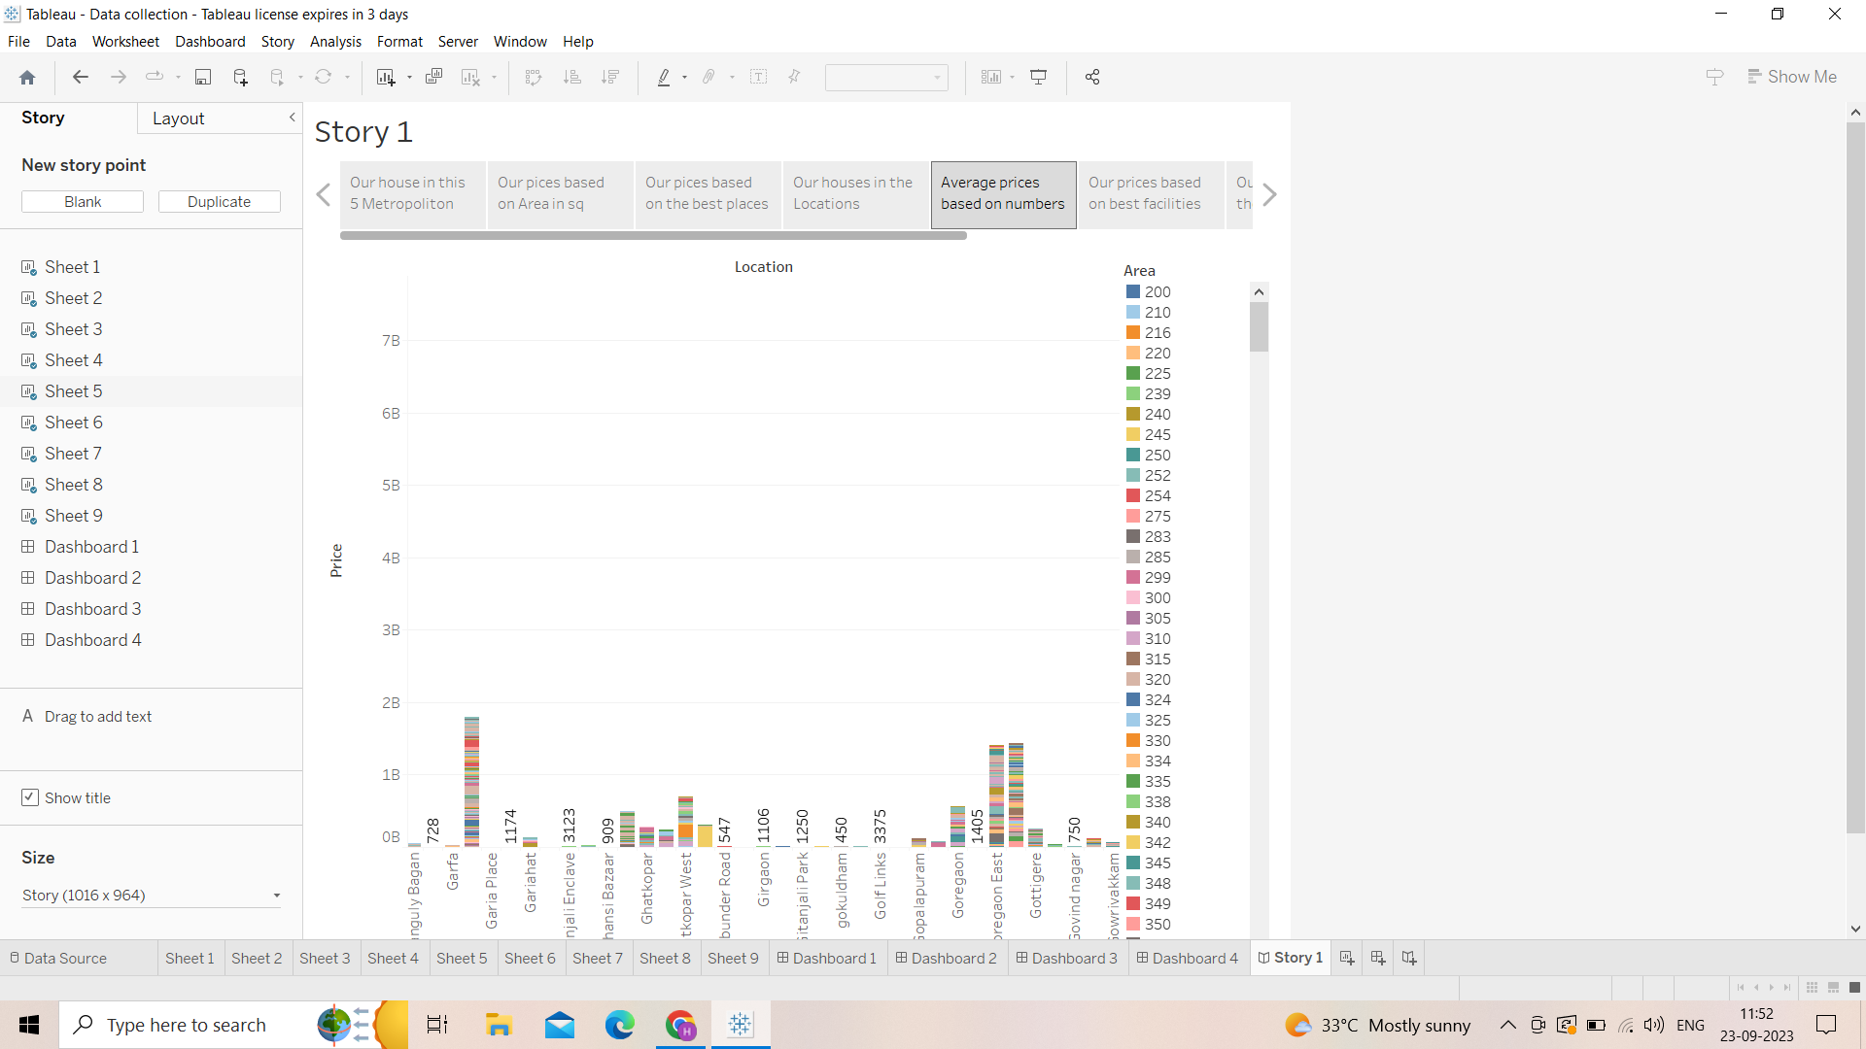  
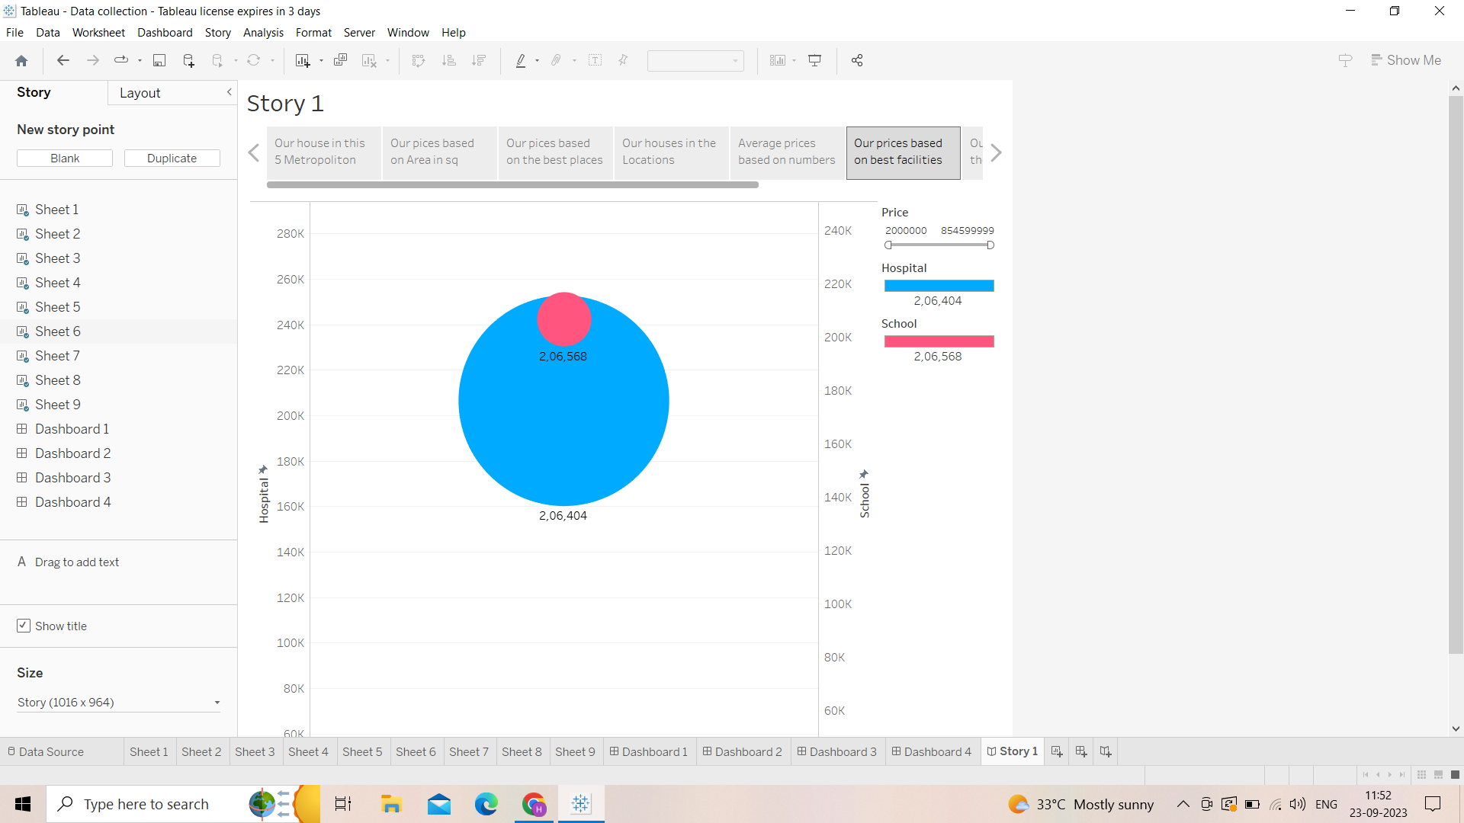

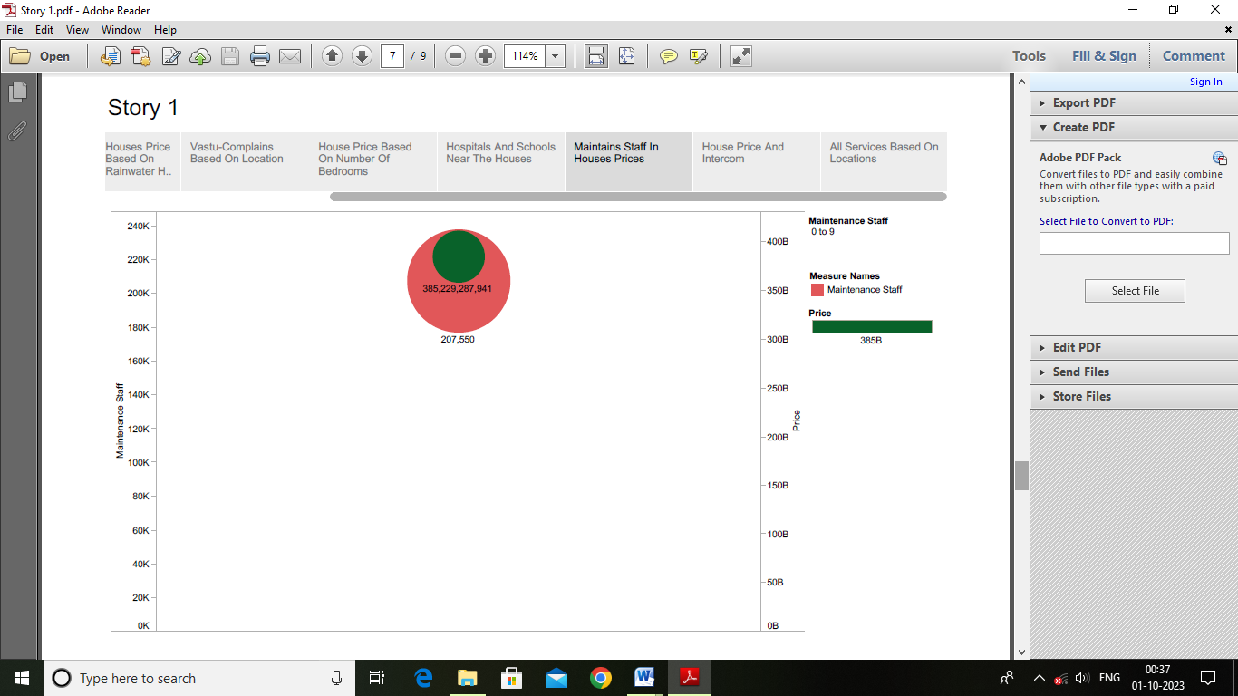

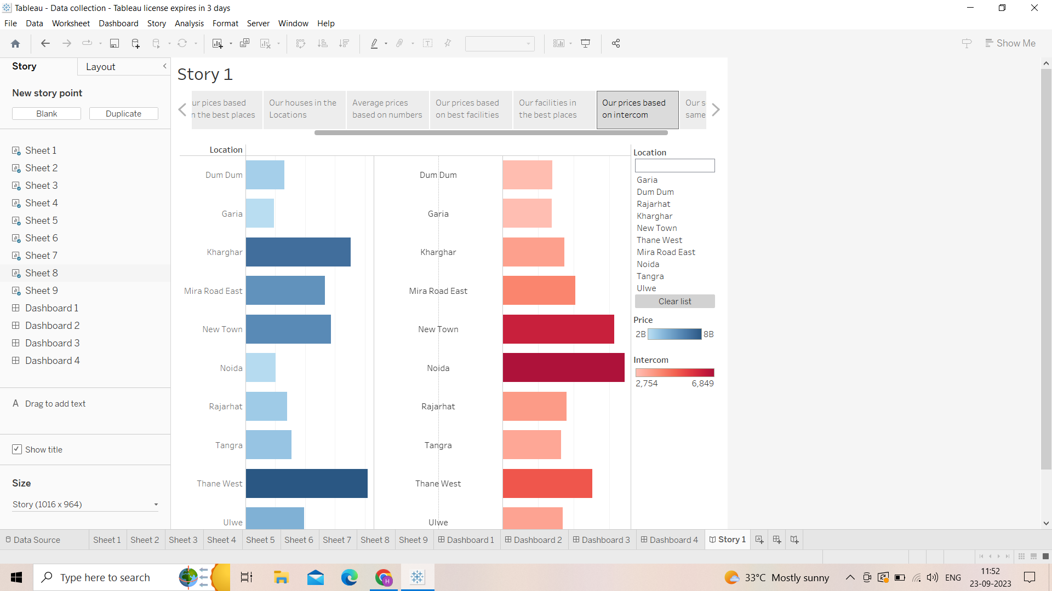

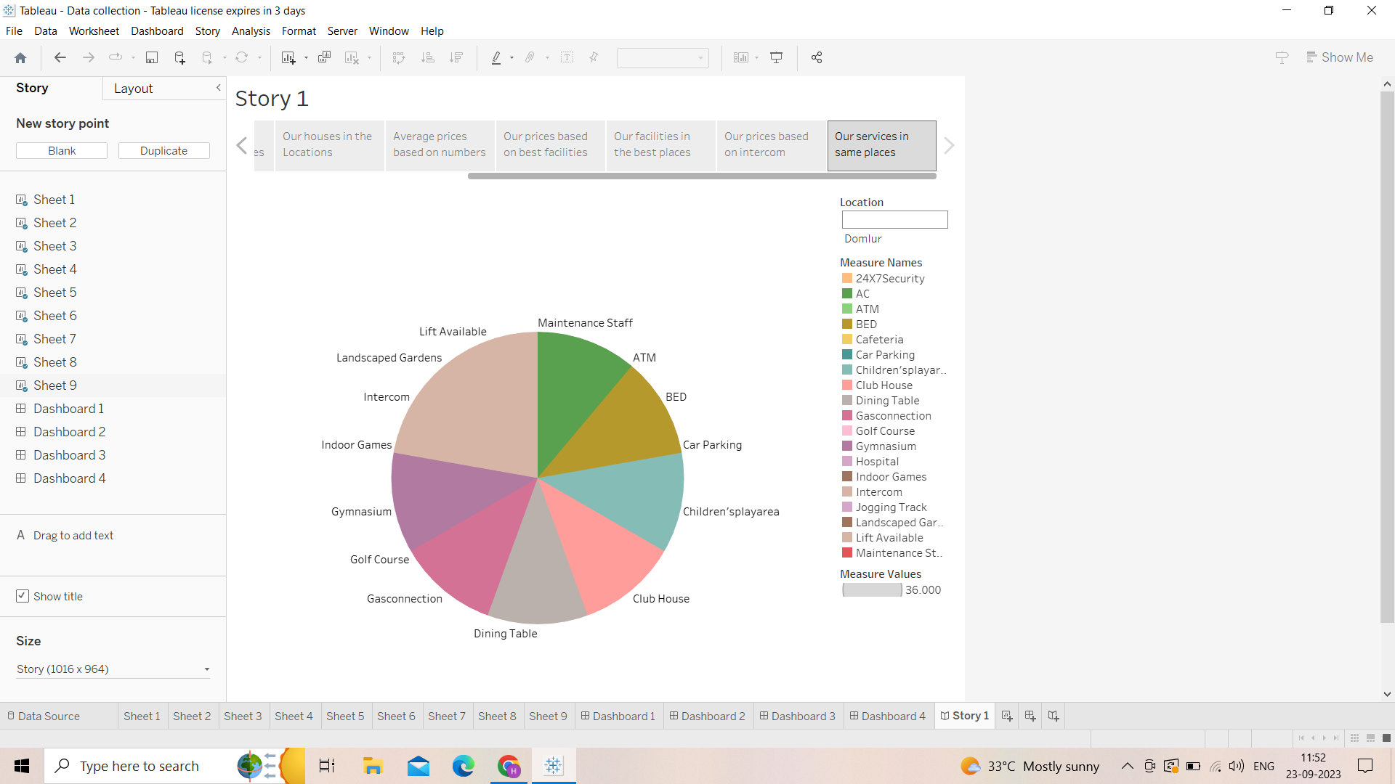

*Milestone 7: Publishing*

Dashboard 1 Link

https://public.tableau.com/views/NM2023TMID08632Dashboard-1/Dashboard1?:language=en-US&:display_count=n&:origin=viz_share_link

Dashboard 2 Link

https://public.tableau.com/views/NM2023TMID08632-Dashbord2/Dashboard2?:language=en-US&:display_count=n&:origin=viz_share_link

Dashboard 3 Link

https://public.tableau.com/views/NM2023TMID08632-Dashbord3/Dashboard3?:language=en-US&:display_count=n&:origin=viz_share_link

Dashboard 4 Link

https://public.tableau.com/views/NM2023TMID08632-Dashbord3/Dashboard3?:language=en-US&:display_count=n&:origin=viz_share_link

Story

https://public.tableau.com/views/NM2023TMID08632-Story/Story1?:language=en-US&:display_count=n&:origin=viz_share_link

CONCLUSION

* Data obtained from local real estate brokers and by the help of geographical information systems and spatial statistics this paper figures a distribution of house prices.The house prices were collected from local real estate brokers’ sales database of 2018. In fiscal terms the brokerages fees are %3 of sales price both %1.5 from seller and buyer share.
* In order to taxation values up to %48 of income gains from property many owners avoid to declare the real prices. The prices of houses that are sold by real estate brokers are collected on street level of geo- coded address code.